Project 1
Blackjack/21

Lucy Badescu
CIS-42375
April 22, 2018

Introduction

Title: Blackjack/21

Blackjack is a popular gambling game often played in casinos. Although the game is fairly simple, there are a few of rules. Like the name suggests, the goal of the game is to score 21 points or to get as close to 21 as possible without going over. The game starts with the player receiving two cards face up and the dealer receiving one card face up and the other face down. If the player’s first two cards make 21 (Blackjack), the dealer reveals it’s second card and if it is also a 21 you tie, otherwise you win. If the dealer’s first card is a 10 or 11, the dealer reveals its second card and if it’s a 21 you lose.
If none of these things occur, the game proceeds as normal and the dealer asks if you wish to “stand” or “hit.” This choice is up to you. If you choose “Hit” the dealer will give you cards, one at a time so that you can get closer to 21. They will stop once you tell them to or if you go over 21. If you go over 21 then it’s a “Bust” and you lose. If your first two cards are close enough to 21 you can choose to “Stand” and thus to not get any more cards. Once you do the dealer will play their hand. The dealer will reveal its second card. If both cards add up to a score under 16, then the dealer is forced to take more cards until he has at least a score of 17 unless they go over 21 first. If the dealer has at least 17 points, then they do not take any more cards. If no player goes over 21 and no one scores an actual 21, then the player closest to 21 wins.

Summary

Project length: 509 lines
Number of variables: 21
Number of constants: 3

The project took about a week to complete.
I ran across a few problems along the way that forced me to rewrite the entire program at least 3 times in hopes of making the program less confusing and all the elements work. I am not entirely happy with how the program turned out and am hoping to make it better for project 2.

For the sake of not going over 1000 lines and to make sure the program wasn’t as confusing, there are a few elements of the game that I left out. In the original game if your first two cards are a pair, you have the option to split them and play two different hands. Because I wasn’t sure how to do this without adding at least 500 lines to each Hand I left this option out.
In the original game, if the dealer has a 10 or 11 you have the option to bet on the face down card if you think it will make a 21. Because I did not consider this to be necessary for the program, since there is no actual money or gambling involved, I decided to leave this out of the game.
Another element that I changed is the point system. In the actual game the cards are scored from 2 to 10 with the face cards holding a value of 10 and the ace being either a 1 or 11. Because the program does not use actual cards I decided to only use the values 2 to 11, the 11 representing the ace.
In this version, the player will play against the program and like in the actual game the player will receive two numbers with the exception of the dealer (the program). The program will reveal its second card later in the game after certain conditions have been meet.

Description

The main point of the game is to get to 21 (or as close as possible) without going over.

Flow Chart
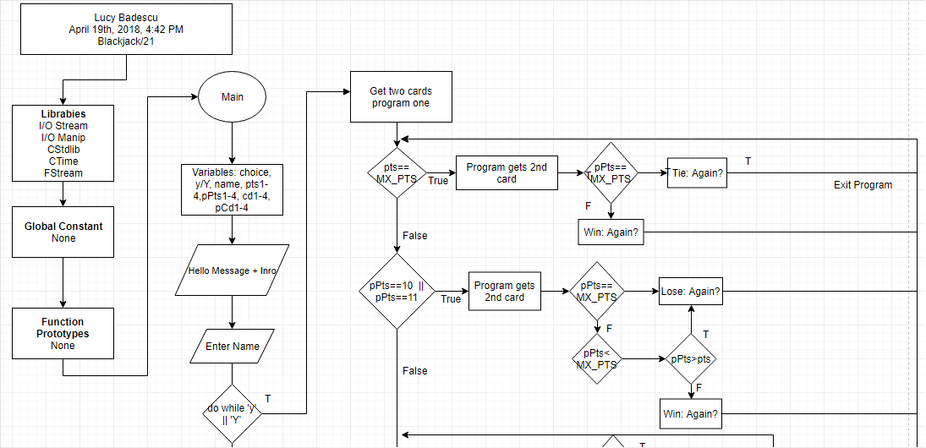

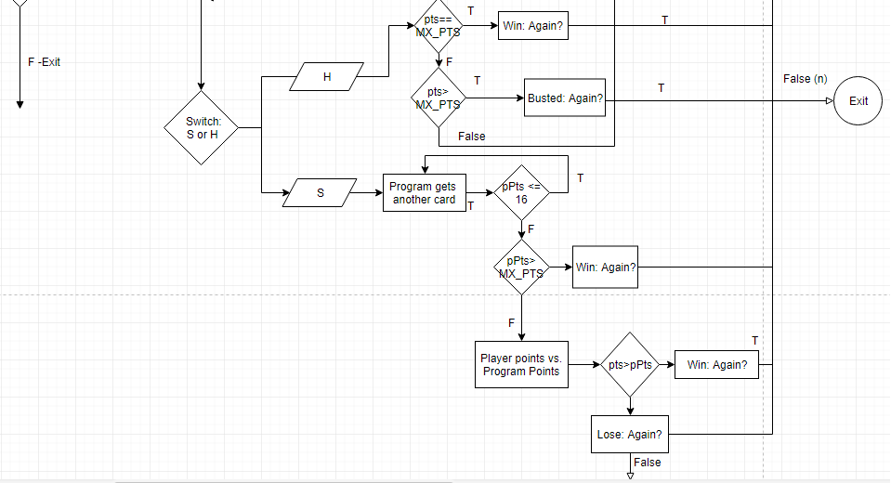

Major Variables

Type | Variable Name | Description | Location
Character  (char) | choice | Player’s choice | Action performed (Enter y,n,s,h)
 | y/Y | To hold Yes (to repeat game) | Action performed (y)
String | name | To hold the player’s name | Starts the game (line 45) and appears sometimes if wins.
Integer (int) | pts1 | To hold player’s points section 1 | First (60)  Last (489)
 | pts2 | To hold player’s points section 2 | First (122)  Last (391) depends on choices.
 | pts3 | To hold player’s points section 3 | First (144)  Last (285) depends on choices.
 | pts4 | To hold player’s points section 4 | First (166)  Last (232) depends on choices.
 | pPts1 | To hold program points sections 1 | First (61)  Last (124)
 | pPts2 | To hold program points section 2 | First (69)  Last (489) depends on choices.
 | pPts3 | To hold program points section 3 | First (200)  Last (467) depends  on choices.
 | pPts4 | To hold program points section 4 | First (211)  Last (446) depends on choices
 | cd1 | To hold player card 1 | First (57)  Last (165)
 | cd2 | To hold player card 2 | First (58)  Last (166)
 | cd3 | To hold player card 3 | First (119)  Last (166) depends on choices.
 | cd4 | To hold player card 4 | First (141)  Last (167) depends on choices.
 | cd5 | To hold player card 5 | First (163)  Last (167) depends on choices.
 | pCd1 | To hold Program card 1 | int()  First (59)  Last (422)
 | pCd2 | To hold Program card 2 | int()  First (67)  Last (423) depends on choices.
 | pCd3 | To hold Program card 3 | int()  First (197)  Last (423) depends on choices.
 | pCd4 | To hold Program card 4 | int()  First (206)  Last (423) depends on choices.
Constants  (const) | MIN_CD & MX_CD | To hold the lowest card value (2) and the largest (11). | When cds or pCds are introduced. For (Rand)
 | MX_PTS | To hold highest combined score/points (21) |  | From (64-274) monitors points.

Cross Reference – Project One
Ch. | Sect. | Topic | Where Line #’s | Pts | Notes
2 | 2 | cout | First(44) Last(491)
 | 3 | libraries | Lines 9-13 | 8 | All libraries used
 | 4 | Variables/literals | 27-33Var/ 61 literal
 | 5 | Identifiers | 27-33 |  | cd1, pPts3, etc
 | 6 | Integers | Into 30-33 | 3 | Used throughout
 | 7 | Characters | 27 | 3 | Choice, y/Y
 | 8 | Stings | 29 (First used 45) | 3 | Name
 | 9 | Floats (No Doubles) | 62 (Only needed int). | 3 | Used for static cast
 | 10 | Bools | 64,193… | 4 | Several in program
 | 11 | Sizeof***** | N/A
 | 12 | Variables (<=7 char) | 30-33 |  | All <= 7 Char
 | 13 | Scope***** | N/A |  | No global variables
 | 14 | Arithmetic Operators | 60, 120, 142… |  | Various sections
 | 15 | Comments (20%+) | 27-38 | 5 | to explain variables
 | 16 | Named Constants | 36-38 (First used 57) |  | Primarily for Rand
 | 17 | Programming Style***** | N/A |  | Mimics that of book
3 | 1 | cin | First 45, last 492
 | 2 | Math Expression | 142, 209, 406… |  | Used throughout
 | 3 | Mixing data types***** | N/A
 | 4 | Overflow/Underflow***** | N/A
 | 5 | Type Casting | 62 | 4
 | 6 | Multiple Assignment***** | N/A
 | 7 | Formatting output | First 63,64 last 483 | 4 | setw()
 | 8 | Strings | 45 | 3 | getline(cin, name)
 | 9 | Math Library | 11 (for rand) | 4 | Random #’s ?
 | 10 | Hand Tracing***** | N/A
4 | 1 | Relational Operators | First 65, last 499 |  | <, >, ==, <=, etc
 | 2 | If | 89 | 4 | Only
 | 4 | If-else | 70/75, 96/101… | 4 | Used throughout
 | 5 | Nesting | 94/96 | 4 | Only
 | 6 | If-else-if | 64/82/109, 123/129/134… | 4 | Used throughout
 | 7 | Flags***** | N/A
 | 8 | Logical Operators | 83 & 499. | 4 | Used: ||
 | 11 | Validating user input | - | 4 | Couldn’t make work
 | 13 | Conditional Operator | - | 4 | Couldn’t make work
 | 14 | Switch | 113, 138, & 160 | 4
5 | 1 | Increment/Decrement | - | 4 | Couldn’t incorporate.
 | 2 | While | - | 4 | Didn’t do anything so took out
 | 5 | Do-while | 53/498 | 4
 | 6 | For loop | - | 4 | Couldn’t use it
 | 11 | Files input/output both | - | 8 | Ran out of time
 | 12 | No breaks in loops***** | N/A
*****Not Required to show |  |  | Total | 100

Reference

Textbook: Tony Gaddis, “Starting Out with C++” - 8th edition.
bicyclecards.com - https://www.bicyclecards.com/how-to-play/blackjack/#filter=.casino //Used as reference to see the rules for blackjack.

Program:

//System Libraries
#include <iostream> //I/O Library -> cout,endl
#include <iomanip> //Format Library
#include <cstdlib> //Rand/Srand
#include <ctime> //Time
#include <fstream> //File i/o
using namespace std;//namespace I/O stream library created

//User Libraries

//Global Constants
//Math, Physics, Science, Conversions, 2-D Array Columns

//Function Prototypes

//Execution Begins Here!

int main() {
//Declare Variables
char choice,//character entered by player
y, Y;//to hold yes
string name;//player name
int pts1, pts2, pts3, pts4,//to hold the points accumulated by player
pPts1, pPts2, pPts3, pPts4,//to hold the program's score
cd1, cd2, cd3, cd4, cd5,//to hold the player card values
pCd1, pCd2, pCd3, pCd4;//to hold the program card values

//Initial Variables
const int MX_PTS=21;//to hold max score
const int MIN_CD=2;//to hold minimum card points
const int MX_CD=11;//to hold max card points
unsigned seed=time(0);

//Map/Process Inputs to Outputs
srand(seed);
//Display Outputs
cout<<"Welcome to Blackjack on C++, please enter your name: ";
getline(cin,name);
cout<<"Hello "<<name<<" I will give you a quick overview of the game.\n";
cout<<"The purpose of the game is to get as close to 21 as possible. \n";
cout<<"It will be you against the program. Because we do not have picture\n";
cout<<"cards, the program will generate random numbers from 2 to 11. \n";
cout<<"If at anytime you wish to stop playing, you may Quit the game\n";
cout<<"by entering 'n' (or any other key). Good luck! \n";
cout<<"-----------------------------------------------------------------\n";
do{
cout<<"You will receive two cards and the program will receive one\n";
cout<<"Your Cards / Program / Your Pts / Program Pts"<<endl;
cout<<"---------------------------------------------------"<<endl;
cd1=(rand()%(MX_CD-MIN_CD+1))+MIN_CD;
cd2=(rand()%(MX_CD-MIN_CD+1))+MIN_CD;
pCd1=(rand()%(MX_CD-MIN_CD+1))+MIN_CD;
pts1=cd1+cd2;
pPts1=pCd1;
pPts1=static_cast<float>(pCd1);
cout<<setw(5)<<cd1<<setw(5)<<cd2<<setw(10)<<pCd1<<setw(10)<<pts1;
cout<<setw(5)<<pPts1<<endl;
if (pts1==MX_PTS)
{
cout<<"The program will reveal it's second card.\n";
pCd2=(rand()%(MX_CD-MIN_CD+1))+MIN_CD;
pPts2=pCd1+pCd2;
cout<<"The program has: "<<setw(5)<<pPts2<<endl;
if (pPts2==MX_PTS)
{
cout<<"You have tied, try again? (y/n): ";
cin>>choice;
}
else
{
cout<<"BLACKJACK! Congratulations "<<name<<" you have won!\n";
cout<<"Would you like to try again? (y/n): ";
cin>>choice;
}
}
else if (pPts1==10 || pPts1==11)
{
cout<<"The program will reveal it's second card.\n";
pCd2=(rand()%(MX_CD-MIN_CD+1))+MIN_CD;
pPts2=pCd1+pCd2;
cout<<"Program Cards: "<<setw(3)<<pCd1<<setw(2)<<pCd2<<setw(2)<<endl;
cout<<"Points: "<<setw(3)<<pPts2<<endl;
if (pPts2==MX_PTS)
{
cout<<"The program wins. Try again? (y/n): ";
cin>>choice;
}
if (pPts2<MX_PTS)
{
if (pPts2>pts1)
{
cout<<"The program wins. Try again? (y/n): ";
cin>>choice;
}
else
{
cout<<"Congratulations, "<<name<<" you win, would you like";
cout<<" to play again?: ";
cin>>choice;
}
}
}
else
{
cout<<"Would you like to stand or hit? (s for stand, h for hit): ";
cin>>choice;
char h,s;//player optional input
switch (choice){
case 'h':
case 'H':{
cout<<"1.The program will give you another card.\n";
cout<<"Your Cards / Program / Your Pts / Program Pts\n";
cout<<"-----------------------------------------------\n";
cd3=(rand()%(MX_CD-MIN_CD+1))+MIN_CD;
pts2=cd1+cd2+cd3;
cout<<setw(5)<<cd1<<setw(5)<<cd2<<setw(5)<<cd3<<setw(10);
cout<<pCd1<<setw(10)<<pts2<<setw(10)<<pPts1<<endl;
if(pts2==MX_PTS)
{
cout<<"BLACKJACK! You have won the round!\n";
cout<<" Would you like to play again? (y/n): ";
cin>>choice;
}
else if (pts2>MX_PTS)
{
cout<<"BUSTED! You lose. Try again? (y/n): ";
cin>>choice;
}
else
{
cout<<"Would you like to stand or hit? (s/h): ";
cin>>choice;
switch (choice){
case 'h':
case 'H':{
cd4=(rand()%(MX_CD-MIN_CD+1))+MIN_CD;
pts3=cd1+cd2+cd3+cd4;
cout<<"2.Player Cards: "<<setw(3)<<cd1<<setw(2);
cout<<cd2<<setw(2)<<cd3<<setw(2)<<cd4<<endl;
cout<<"Points: "<<setw(3)<<pts3<<endl;
if(pts3==MX_PTS)
{
cout<<"BLACKJACK! Congratulations you win ";
cout<<"Play again? (y/n): ";
}
else if (pts3>MX_PTS)
{
cout<<"BUSTED! You lose. Try again? (y/n): ";
cin>>choice;
}
else
{
cout<<"Would you like to stand or hit? (s/h): ";
cin>>choice;
switch (choice){
case 'h':
case 'H':{
cd5=(rand()%(MX_CD-MIN_CD+1))+MIN_CD;
pts4=cd1+cd2+cd3+cd4+cd5;
cout<<"3.Player Cards: "<<setw(3)<<cd1;
cout<<setw(2)<<cd2<<setw(2)<<cd3;
cout<<setw(2)<<cd4<<setw(2)<<cd5<<endl;
cout<<"Points: "<<setw(3)<<pts4<<endl;
if(pts4==MX_PTS)
{
cout<<"BLACKJACK! Congratulations";
cout<< name<<" you have won the";
cout<<" round! Would you like to ";
cout<<"play again? (y/n): ";
cin>>choice;
}
else if (pts4>MX_PTS)
{
cout<<"BUSTED! You lose.";
cout<<"Try again? (y/n): ";
cin>>choice;
}
}
case 's':
case 'S':{
cout<<"3.The program receives another";
cout<<" card.\n";
pCd2=(rand()%(MX_CD-MIN_CD+1))+MIN_CD;
pPts2=pCd1+pCd2;
cout<<"Program cards: "<<setw(3);
cout<<pCd1<<setw(2)<<pCd2<<endl;
cout<<"Points: "<<setw(3)<<pPts2<<endl;
if (pPts2<=16)
{
cout<<"3A.The program receives";
cout<<" another card.\n";
pCd3=(rand()%(MX_CD-MIN_CD+1))+MIN_CD;
pPts3=pCd1+pCd2+pCd3;
cout<<"Program cards: ";
cout<<setw(3)<<pCd1<<setw(2)<<pCd2;
cout<<setw(2)<<pCd3<<endl;
cout<<"Points: "<<setw(3)<<pPts3;
cout<<endl;
if(pPts3<=16)
{
cout<<"3B.The program receives";
cout<<" another card.\n";
pCd4=(rand()%(MX_CD-MIN_CD+1))+MIN_CD;
pPts4=pCd1+pCd2+pCd3+pCd4;
cout<<"Program cards: "<<endl;
cout<<setw(3)<<pCd1;
cout<<setw(2)<<pCd2;
cout<<setw(2)<<pCd3;
cout<<setw(2)<<pCd4<<endl;
cout<<"Points: ";
cout<<setw(3)<<pPts4<<endl;
if(pPts4>MX_PTS)
{
cout<<"Congratulations";
cout<<" you win! Play";
cout<<" again? : ";
cin>>choice;
}
else
{
cout<<"Player Points: ";
cout<<setw(3)<<pts4<<endl;
cout<<"Program Points: ";
cout<<setw(3)<<pPts4<<endl;
if (pts4>pPts4)
{
cout<<"Winner! Play";
cout<<" again? ";
cin>>choice;
}
else
{
cout<<"You lose. Play";
cout<<"again? ";
cin>>choice;
}
}
}
else if (pPts3>MX_PTS)
{
cout<<"Congratulations you ";
cout<<"win! Try again? (y/n): ";
cin>>choice;
}
else
{
cout<<"Player points: ";
cout<<setw(3)<<pts3<<endl;
cout<<"Program Points: ";
cout<<setw(3)<<pPts3<<endl;
if (pts3>pPts3)
{
cout<<"Congratulations ";
cout<<name<<" you win! ";
cout<<"Play again? (y/n): ";
cin>>choice;
}
else
{
cout<<"You lose, play";
cout<<" again? (y/n): ";
cin>>choice;
}
}
}
else if (pPts2>MX_PTS)
{
cout<<"Congratulations you win!";
cout<<" Play again? (y/n): ";
cin>>choice;
}
else
{
cout<<"Player points: "<<setw(3);
cout<<pts3<<endl;
cout<<"Program Points: "<<setw(3);
cout<<pPts2<<endl;
if (pts3>pPts2)
{
cout<<"Congratulations ";
cout<<name<<" you win!";
cout<<" Play again?: ";
cin>>choice;
}
else
{
cout<<"You lose, play again? ";
cin>>choice;
}
}
}
break;
}
break;
}
break;
}
case 's':
case 'S':{
cout<<"2.The program receives another card.\n";
pCd2=(rand()%(MX_CD-MIN_CD+1))+MIN_CD;
pPts2=pCd1+pCd2;
cout<<"Program cards: "<<setw(3)<<pCd1;
cout<<setw(2)<<pCd2<<endl;
cout<<"Points: "<<setw(3)<<pPts2<<endl;
if (pPts2<=16)
{
cout<<"2A.The program receives another card.\n";
pCd3=(rand()%(MX_CD-MIN_CD+1))+MIN_CD;
pPts3=pCd1+pCd2+pCd3;
cout<<"Program cards: "<<setw(3)<<pCd1;
cout<<setw(2)<<pCd2<<setw(2)<<pCd3<<endl;
cout<<"Points: "<<setw(3)<<pPts3<<endl;
if(pPts3<=16)
{
cout<<"2B.The program receives another card.\n";
pCd4=(rand()%(MX_CD-MIN_CD+1))+MIN_CD;
pPts4=pCd1+pCd2+pCd3+pCd4;
cout<<"Program cards: "<<setw(3)<<pCd1;
cout<<setw(2)<<pCd2<<setw(2)<<pCd3<<setw(2);
cout<<pCd4<<endl;
cout<<"Points: "<<setw(3)<<pPts4<<endl;
if(pPts4>MX_PTS)
{
cout<<"Congratulations you win! ";
cout<<"Play again? (y/n): ";
cin>>choice;
}
else
{
cout<<"Program Points: "<<setw(4);
cout<<pPts4<<endl;
cout<<"Player Points: "<<setw(5);
cout<<pts2<<endl;
if (pts2>pPts4)
{
cout<<"Congrats! You win! ";
cout<<"Play again? (y/n): ";
cin>>choice;
}
else
{
cout<<"You lose. Play again? ";
cin>>choice;
}
}
}
else if (pPts3>MX_PTS)
{
cout<<"Congratulations you win! Try again? : ";
cin>>choice;
}
else
{
cout<<"Player points: "<<setw(3)<<pts2<<endl;
cout<<"Program Points: "<<setw(3)<<pPts3<<endl;
if (pts2>pPts3)
{
cout<<"Congratulations "<<name;
cout<<" you win! Play again? : ";
cin>>choice;
}
else if (pts2==pPts3)
{
cout<<"Tie, try again? ";
cin>>choice;
}
else
{
cout<<"You lose. Play again? : ";
cin>>choice;
}
}
}
else if (pPts2>MX_PTS)
{
cout<<"Congratulations you win! Try again? (y/n): ";
cin>>choice;
}
else
{
cout<<"Player points: "<<setw(3)<<pts2<<endl;
cout<<"Program Points: "<<setw(3)<<pPts2<<endl;
if (pts2>pPts2)
{
cout<<"Congratulations "<<name<<" you win!";
cout<<" Play again? (y/n): ";
cin>>choice;
}
else
{
cout<<"You lose, play again? (y/q): ";
cin>>choice;
}
}
}
break;
}
}
}break;
case 's':
case 'S':{
cout<<"1.The program receives another card.\n";
pCd2=(rand()%(MX_CD-MIN_CD+1))+MIN_CD;
pPts2=pCd1+pCd2;
cout<<"Program cards: "<<setw(3)<<pCd1<<setw(2)<<pCd2<<endl;
cout<<"Points: "<<setw(3)<<pPts2<<endl;
if (pPts2<=16)
{
cout<<"1A.The program receives another card.\n";
pCd3=(rand()%(MX_CD-MIN_CD+1))+MIN_CD;
pPts3=pCd1+pCd2+pCd3;
cout<<"Program cards: "<<setw(3)<<pCd1<<setw(2);
cout<<pCd2<<setw(2)<<pCd3<<endl;
cout<<"Points: "<<setw(3)<<pPts3<<endl;
if(pPts3<=16)
{
cout<<"1B.The program receives another card.\n";
pCd4=(rand()%(MX_CD-MIN_CD+1))+MIN_CD;
pPts4=pCd1+pCd2+pCd3+pCd4;
cout<<"Program cards: "<<setw(3)<<pCd1<<setw(2);
cout<<pCd2<<setw(2)<<pCd3<<setw(2)<<pCd4<<endl;
cout<<"Points: "<<setw(3)<<pPts4<<endl;
if(pPts4>MX_PTS)
{
cout<<"Congratulations you win! Try again?";
cout<<" (y/n): ";
cin>>choice;
}
else
{
cout<<"Program Points: "<<setw(4)<<pPts4<<endl;
cout<<"Player Points: "<<setw(5)<<pts1<<endl;
if (pts1>pPts4)
{
cout<<"Congrats, you win! Play again? ";
cin>>choice;
}
else if (pts1==pPts4)
{
cout<<"It's a tie, try again? ";
cin>>choice;
}
else
{
cout<<"You lose, try again? ";
cin>>choice;
}
}
}
else if (pPts3>MX_PTS)
{
cout<<"Congratulations you win! Try again? (y/n): ";
cin>>choice;
}
else
{
cout<<"Player points: "<<setw(5)<<pts1<<endl;
cout<<"Program Points: "<<setw(4)<<pPts3<<endl;
if (pts1>pPts3)
{
cout<<"Congratulations "<<name<<" you win!";
cout<<" play again? (y/n): ";
cin>>choice;
}
else
{
cout<<"You lose, play again?(y/n): ";
cin>>choice;
}
}
}
else if (pPts2>MX_PTS)
{
cout<<"Congratulations you win! Try again? (y/n): ";
cin>>choice;
}
else
{
cout<<"Player points: "<<setw(5)<<pts1<<endl;
cout<<"Program Points: "<<setw(4)<<pPts2<<endl;
if (pts1>pPts2)
{
cout<<"Congratulations "<<name<<" you have won!";
cout<<" would you like to play again? (y/n): ";
cin>>choice;
}
else
{
cout<<"You lose, play again? (y/n): ";
cin>>choice;
}
}
}
break;
}
}
}while (choice=='y' || choice=='Y');

//Exit program!
return 0;
}

